1. Frog Hopping
- Green frog (import) hopping up and down the screen with platforms above it for it to jump on
- More variations of frog pics
- Platforms generated randomly when the frog goes higher
- +1 for every successful jump
- When frog falls below the screen, “game over” message appears and restart by pressing ‘r’
- Frog always starts on a platform
🐸 Project 1: Frog Hopping
1️⃣ Major Coding Concepts & Techniques
You’ll likely use:
Variables – frog position, speed, gravity, score, game state.
Conditionals (if / else) – checking collisions, game over, restart key.
Loops (for / while) – possibly for iterating through platforms.
Arrays / ArrayLists – to store and manage multiple platform objects.
Objects / Classes – defining Frog and Platform as separate classes.
Random generation – for creating new platforms at random x-positions and heights.
PImage – for loading and displaying frog and background images.
Key input (keyPressed()) – to control jumps or restart.
Physics simulation basics – vertical velocity, gravity, jump impulse.
Text rendering – display “Game Over” and score.
Collision detection – checking if the frog lands on a platform.
Game state management – play, game over, restart.
2️⃣ Trickiest / Most Complicated Concepts
Collision detection (frog ↔ platform) — requires bounding box logic or overlap conditions.
Procedural generation of platforms — ensuring platforms appear in playable positions.
Gravity and jumping physics — getting a natural-feeling hop motion (acceleration, velocity reset).
ArrayList management — adding/removing platforms as the game scrolls upward.
Scrolling / camera logic — making the game world move as the frog climbs.
3️⃣ Recommended Step-by-Step Plan
Set up the canvas and draw a simple static frog using a rectangle or ellipse.
Make the frog jump:
Add velocity and gravity variables.
Implement keyPressed() to jump (set upward velocity).
Add basic ground/platform:
Draw one rectangle the frog can land on.
Detect when frog’s feet are touching it.
Make multiple platforms:
Use an ArrayList<Platform> to store them.
Draw them all in a for loop.
Scrolling effect:
As the frog jumps higher, move the screen (or move all platforms downward).
Random generation:
Add new platforms above when old ones go off-screen.
Add scoring system:
+1 when landing on a new platform.
Add game-over logic:
If frog.y > height → show “Game Over” and wait for restart key.
Polish:
Import frog PImages, add different frog pictures for animation.
Display score, restart key, background image, etc.

2. Catching Color
- Rectangle box at the bottom of the screen with circular colors falling
- Red = -3
- Green = +5
- Blue = +2
- Miss five balls/hit the ground means player loses
- After a certain score, balls will fall faster
- When miss five balls/hit the ground, “game over” message appears and restart by pressing ‘r’
🎨 Project 2: Catching Color
1️⃣ Major Coding Concepts & Techniques
You’ll likely use:
Variables – score, misses, speed, game state.
Arrays / ArrayLists – to store multiple falling balls.
Objects / Classes – define Ball (color, x, y, speed).
Random generation – random x-position and color of falling balls.
Conditionals – detect collision between falling ball and player box.
Key input – move box left/right.
Game loop logic – update ball positions every frame.
Text display – score, misses, and “Game Over”.
Restart logic – reset all values when pressing ‘r’.
2️⃣ Trickiest / Most Complicated Concepts
Collision detection between a falling circle and player rectangle.
Managing multiple objects (balls) — using ArrayList to create, move, and remove them.
Difficulty scaling — gradually increasing fall speed with score.
Game reset — clearing all arrays and resetting variables properly.
3️⃣ Recommended Step-by-Step Plan
Draw player box at bottom of screen and move it left/right with keys.
Create one falling ball (a circle).
Make it fall using y += speed.
Reset it when it goes off-screen.
Add collision detection:
If the ball touches the box → update score based on color.
Add multiple balls:
Store them in an ArrayList<Ball>.
Randomize color and x-position.
Track misses:
When a ball reaches the bottom without being caught → misses++.
Add difficulty scaling:
Increase speed every few points.
Game-over logic:
If misses >= 5, display “Game Over” and stop movement.
Restart feature:
Press r to reset score, miss, and recreate balls.
Polish:
Add color-coded scoring, nice background, text alignment, etc.

11/4/2025
Goals for the day:
- Setup variables
- Input image
- Maybe try and do platforms
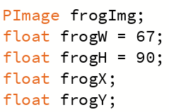
Today I accomplished:
Inputting my image, setting my variables and making the sizes
and the number of platforms I want on my screen every time.
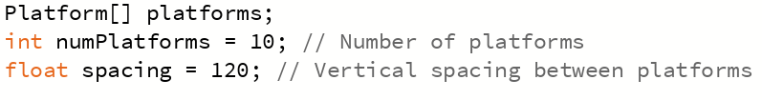
Problems I encountered:
My image was too big at first, so I resized it, my image
also had a write background which I removed.
Notes for next class:
Do finish array and start on gravity and jumping.

11/6/2025
Goals for the day:
- Set up platforms
- Start adding gravity and jumping

Today I accomplished:
Setting up the platform and adding gravity and jumping.
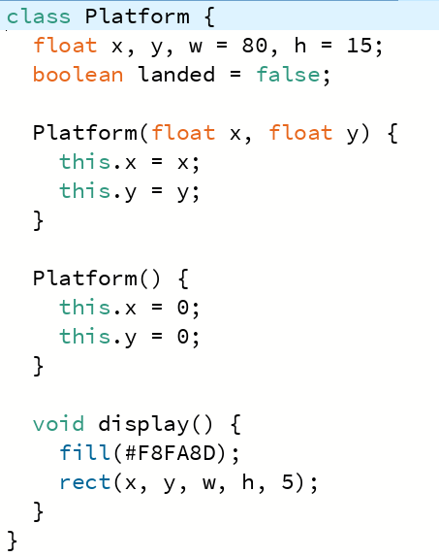
Problems I encountered:
The frog wasn’t jumping.
Notes for next class:
Fix frog and start getting the screen to move everytime the frog gets to a certain height.

11/10/2025
Goals for the day:
- Moving screen
- Make frog land on platform
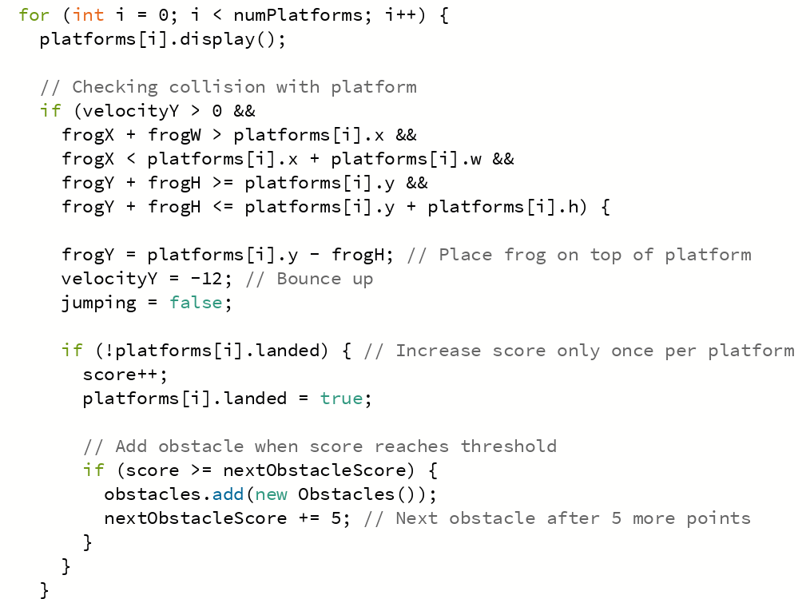
Today I accomplished:
Fixing the gravity and jumping for the frog. Understanding
how to make the frog land on the platform.
Problems I encountered:
The frog getting stuck in the middle of the screen and the screen not moving down.
Notes for next class:
Add score and when to +1 to the score.

11/12/2025
Goals for the day:
- Make frog move side to side

Today I accomplished:
Getting the frog to land and move it side to side.
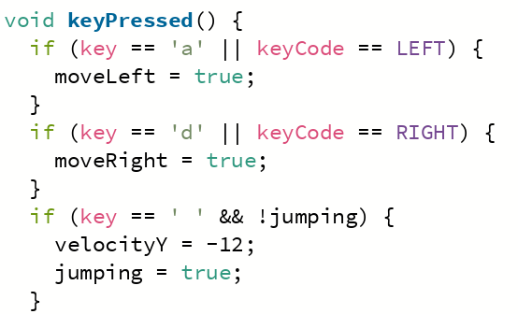
Problems I encountered:
The frog moving off the screen.
Notes for next class:
Finish frog and platforms and start adding score system.

11/12/2025
Goals for the day:
- Make the screen move down
- Score system

Today I accomplished:
Making the screen move and setting the score system.
Problems I encountered:
Every time the frog jumped the screen moved.
The score was adding every pixel.
Notes for next class:
Do game over and restart screen

11/18/2025
Goals for the day:
- Game over and Restart screen

Today I accomplished:
Making the screen change when the player falls below the screen.
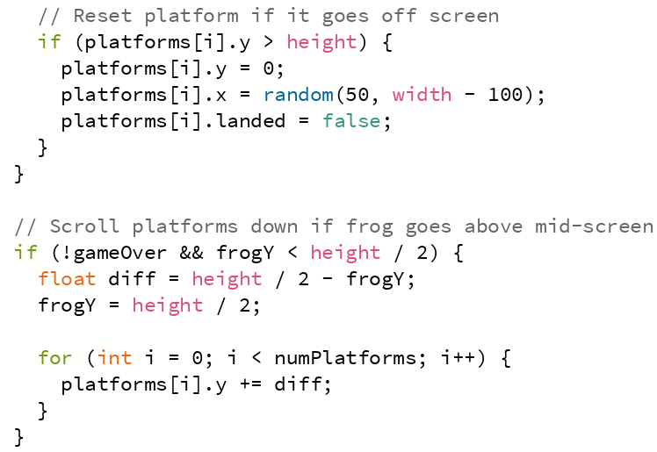

Problems I encountered:
The screen wasn’t changing.
Notes for next class:
Use a letter to restart the game and add obstacles

11/20/2025
Goals for the day:
- Obstacles
- Letter to restart game

Today I accomplished:
Getting the obstacles to work and being able to restart the game.
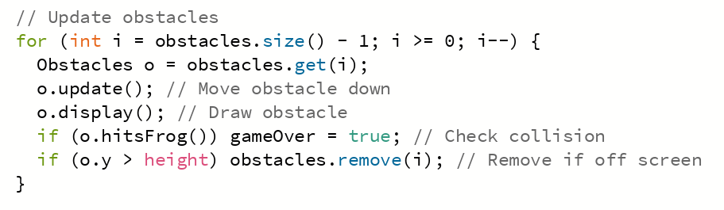
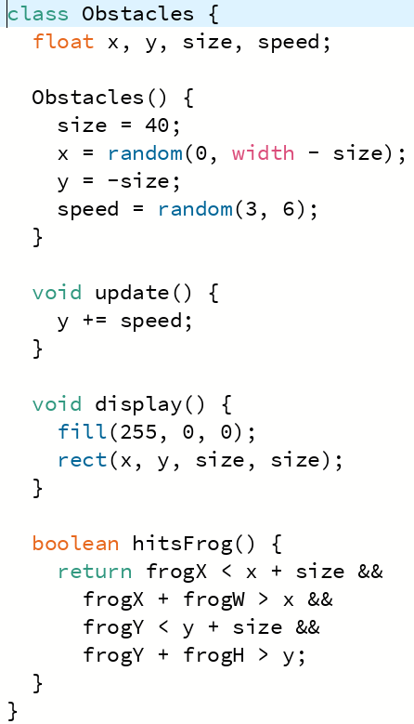
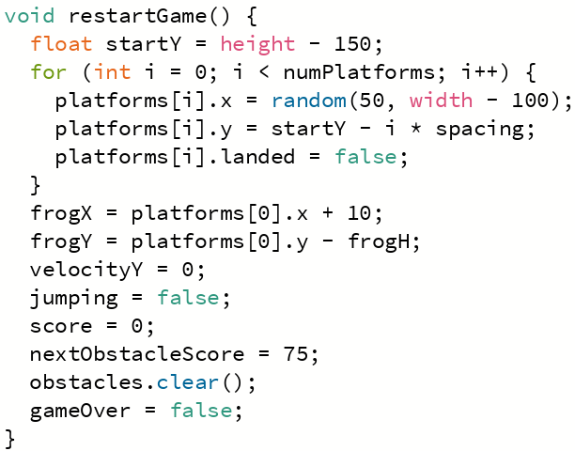
Problems I encountered:
I realized that my score text keeps shifting positions
Notes for next class:
Fix shifting of score

11/24/2025
Goals for the day:
- Fix score shifting
- Add music

Today I accomplished:
Adding music
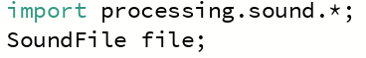
Problems I encountered:
The score keeps moving.
Notes for next class:
Try to fix it again

11/26/2025
Goals for the day:
- Fix score shifting

Today I accomplished:
Stopping it from shifting.
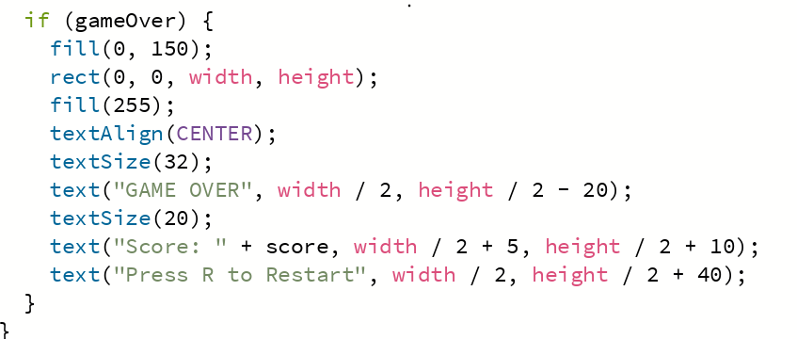
Problems I encountered:
Finding the reason for the shift.
Notes for next class:
Touch up, add pics on word doc and fix screen hang.

12/2/2025
Goals for the day:
- Touch up
- Add pics on word doc
- Screen hang

Today I accomplished:
Touching up, adding the photos and fixing the screen hang.
Problems I encountered:
Not knowing why it was hanging and going through the whole draw code.
Notes for next class:
Continue adding pics

12/4/2025
Goals for the day:
- Add pics on word doc

Today I accomplished:
Adding the photos.
Problems I encountered:
No problems
Notes for next class:
Continue adding pics

12/8/2025
Goals for the day:
- Add pics on word doc

Today I accomplished:
Adding the photos
Problems I encountered:
No problems
Notes for next class:
Continue adding pics

12/10/2025
Goals for the day:
- Add pics on word doc

Today I accomplished:
Adding the photos
Problems I encountered:
No problems
Notes for next class:
Continue adding pics

